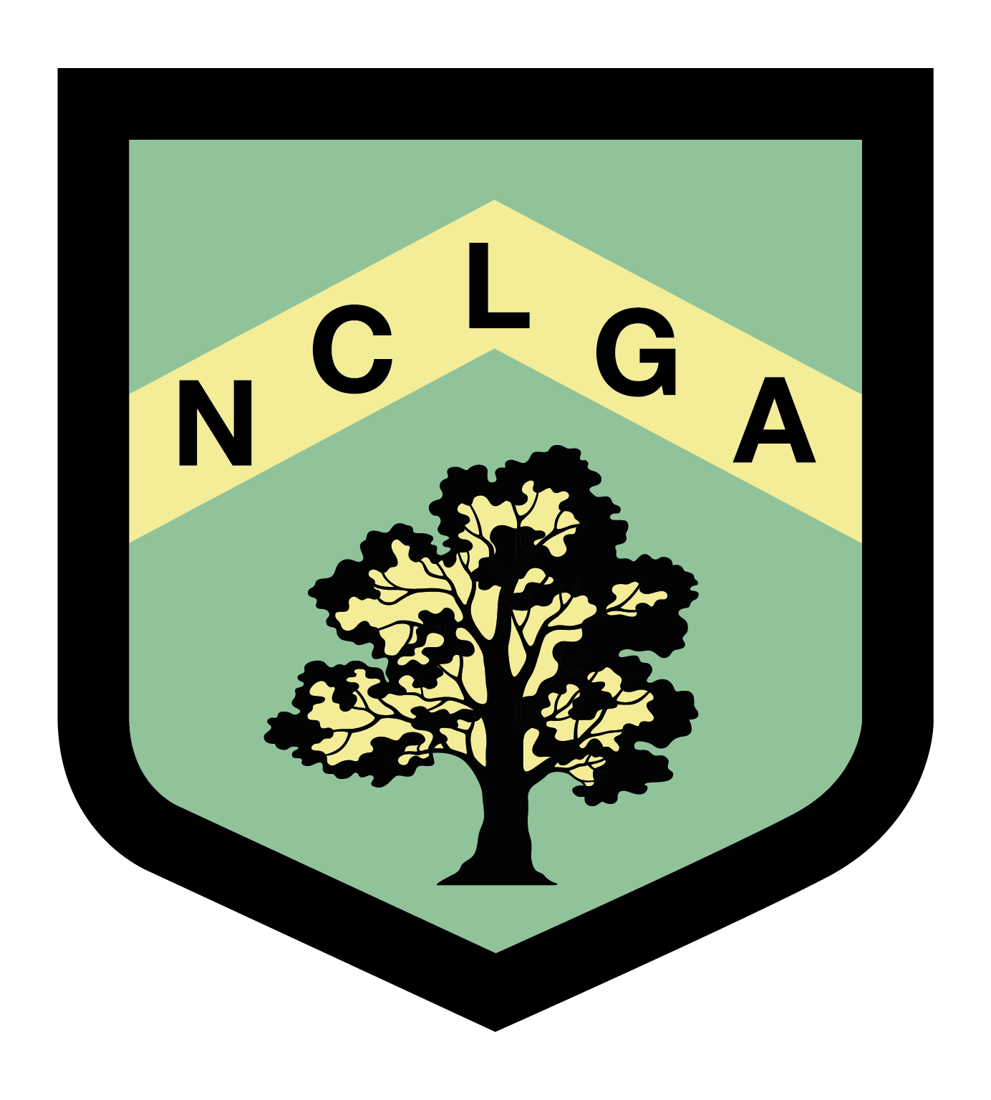
NOTTS COUNTY LADIES GOLF ASSOCIATION

LEAGUE MATCH RESULTS

League………………………… Round……………………………..
Silver/Bronze

Date Played……………………………

Venue…………………………………………

……………………………………….. v ………………………………………

 | Home Team | Handicap | Winning score | Away Team | Handicap | Winning score
1
2

3

4

5

6

7

Result…………………………………..
Name …………………………………. Email …………………………………………….

Winning team to send in results to:
Sue Robinson
27 Penzance Place, Mansfield
Notts, NG18 3ER
leagues@nclga.org.uk

