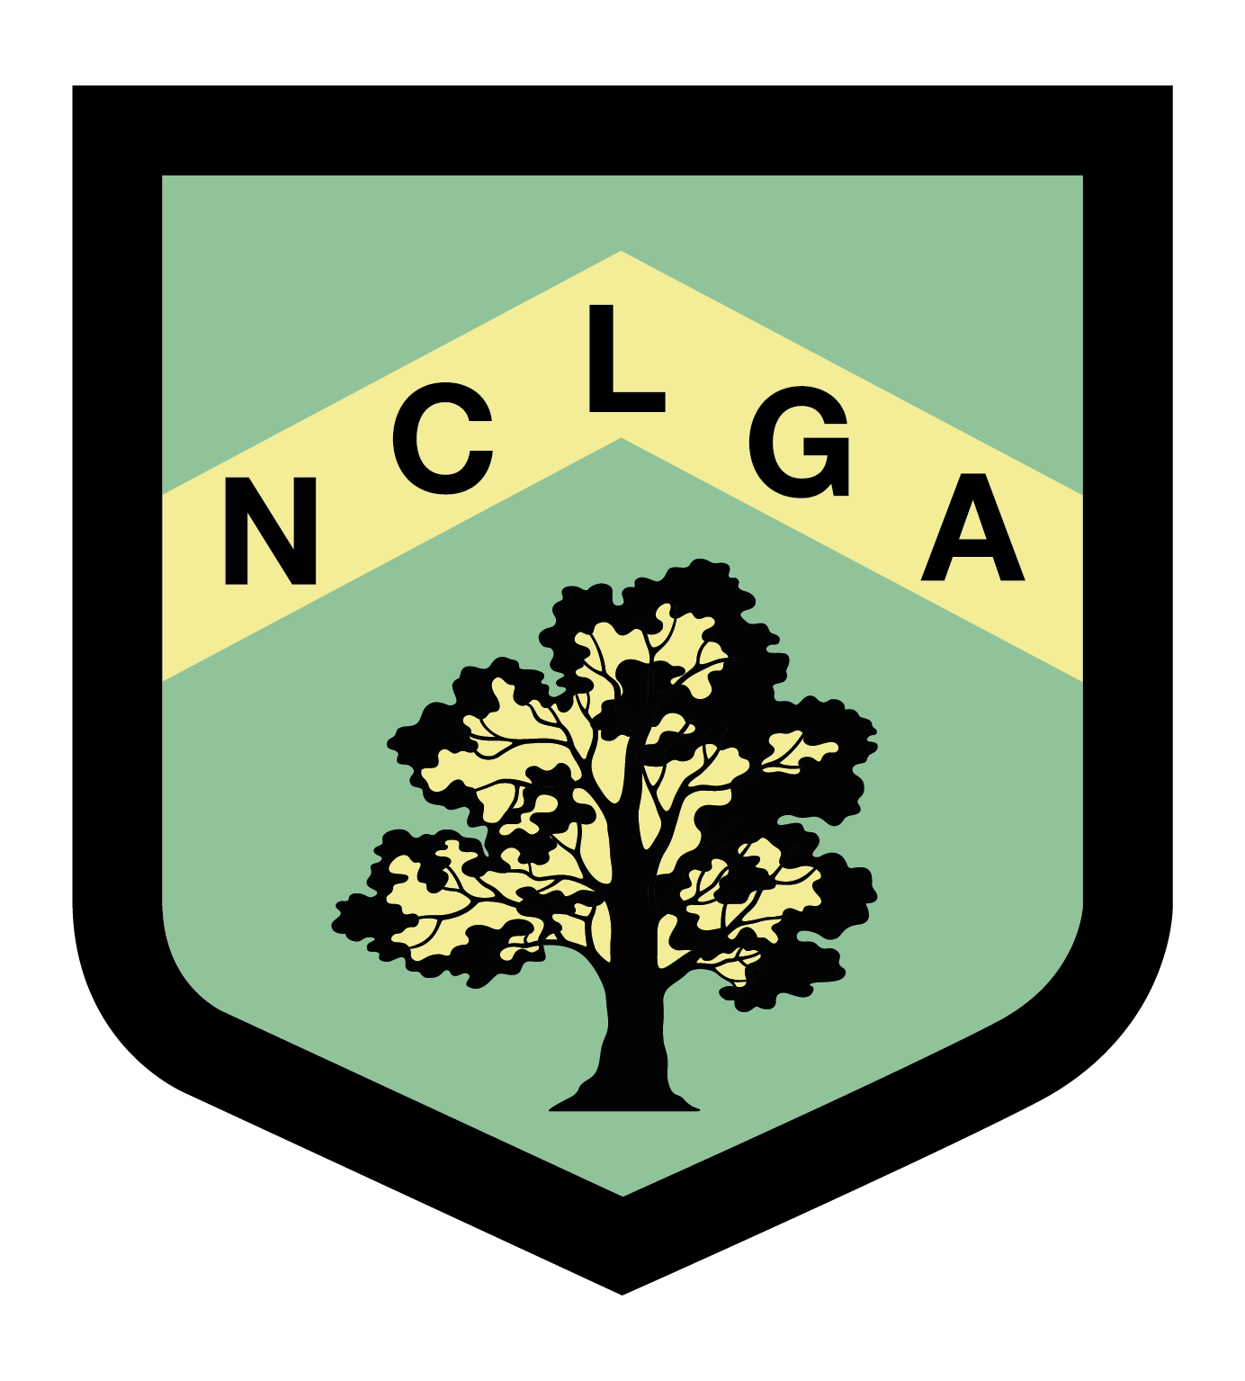
NOTTS COUNTY LADIES GOLF ASSOCIATION

SILVER/BRONZE LEAGUE MATCH RESULTS

League………………………… Venue……………………………………………….. Date Played……………………………
Silver/Bronze

Match | Home Team | H’cap Index | Course H’cap | shots | Winning score | Away Team | H’cap Index | Course H’cap | shots | Winning score
1
2
3
4
5
6
7
Matches Won |  |  |  |  |  | Matches Won

Name ……………………………………………….. Email …………………………………………………….

Winning team to send results to: Sue Robinson leagues@nclga.org.uk 27 Penzance Place,
Mansfield
Notts, NG18 3ER

