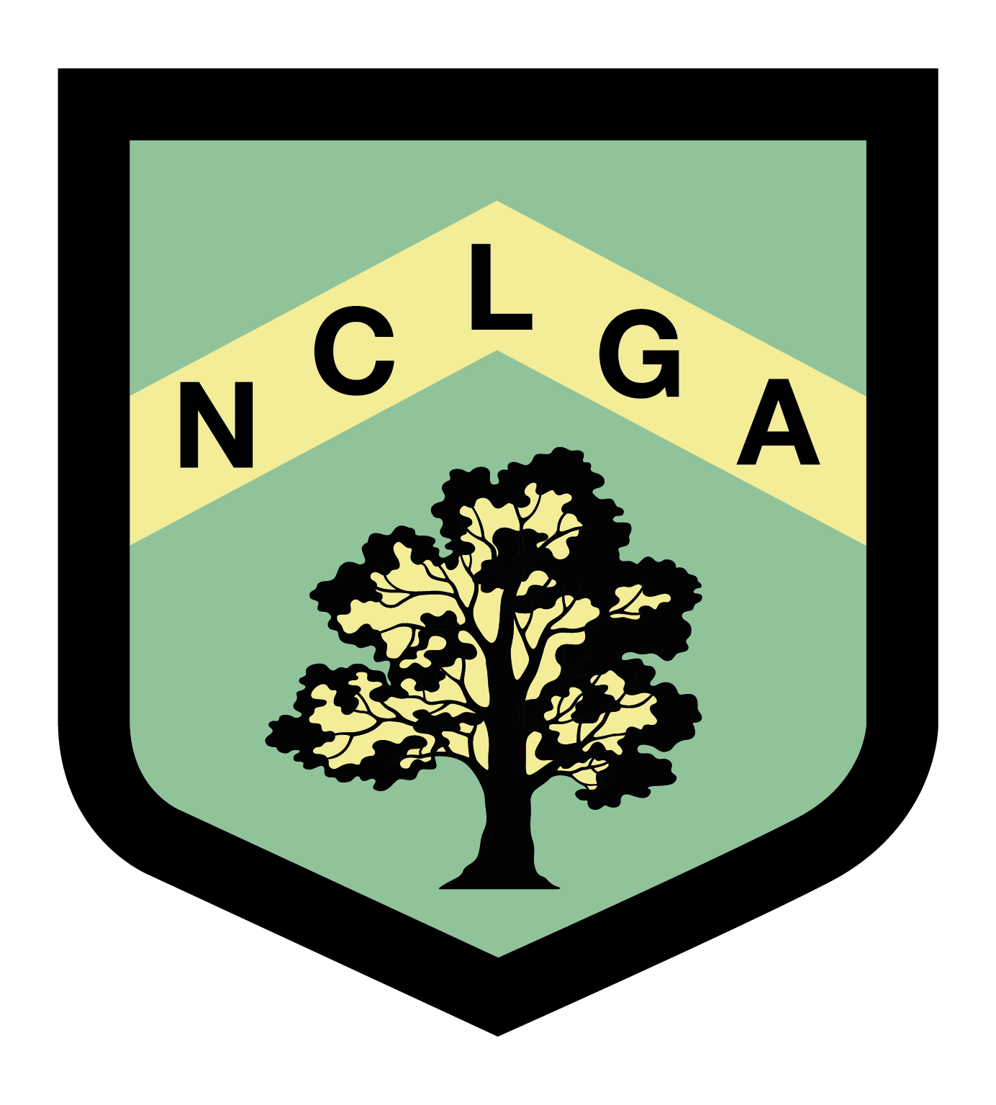
NOTTS COUNTY LADIES GOLF ASSOCIATION

SILVER/BRONZE LEAGUE MATCH RESULTS

League………………………… Venue………………………………………………. Date Played……………………………
Silver/Bronze

Match | Home Team | H’cap Index | Course H’cap | shots | Winning score | Away Team | H’cap Index | Course H’cap | shots | Winning score
1
2
3
4
5
6
7
Matches Won |  |  |  |  |  | Matches Won

Name ……………………………………………….. Email …………………………………………………….

Winning team to send results to: Sue Maine suemaine1@gmail.com 22 Sheepwash Way,
East Leake,
Loughborough, LE12 6WJ

