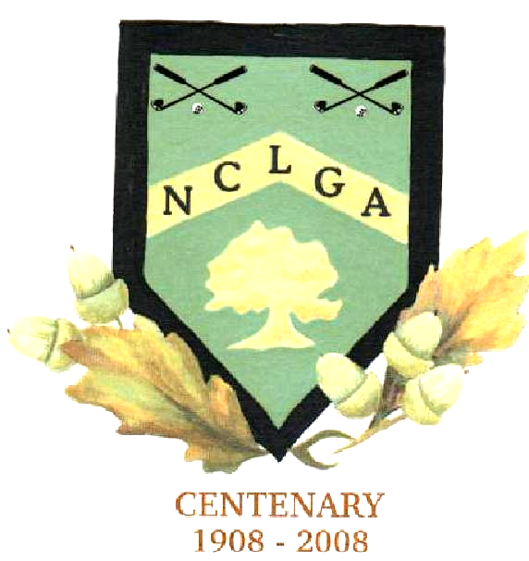
NOTTS COUNTY LADIES GOLF ASSOCIATION

LEAGUE MATCH RESULTS

League………………………… Round……………………………..
Silver/Bronze

Date……………………………

Venue…………………………………………

……………………………………….. v ………………………………………

 | Home Team | Handicap | Winning score | Away Team | Handicap | Winning score
1
2

3

4

5

6

7

Result…………………………………..
Name …………………………………. Email …………………………………………….

Winning team to send in results
Colette Newton
The Four Winds, Rushy Lane
Risley, Derbyshire DE72 3SW
colette@fourwindstextiles.co.uk

